Arteriovenous Fistula with outflow stenosis.
Stem: 58 year old male with end stage renal disease presents to the emergency department with redness and thinning skin overlying his left brachiocephalic arteriovenous fistula. You are called to see the patient emergently because of reports from the dialysis center that they had difficulty stopping the bleeding from one of the sites after dialysis earlier today. The ER physician has outlined the areas that she is concerned with.
PMH:
ESRD, HTN, medullary cystic GN,
PSH:
Left AVF, Appendectomy as a child
Medications:
Amlodipine, calcitriol, atorvastatin
Physical Exam:
Temp 99.5
HR 102
RR 21
BP 185/87
GEN: Alert and oriented x3
EXT: Left AVF is very pulsatile but has a component of a thrill with an audible bruit. There are three areas of aneurysmal dilation two of which have some associated erythema (as seen in the picture).
Labs:
WBC 14K; H/H 9/27: PLT 270K
CO2 18, CR 5.7, K 4.9.
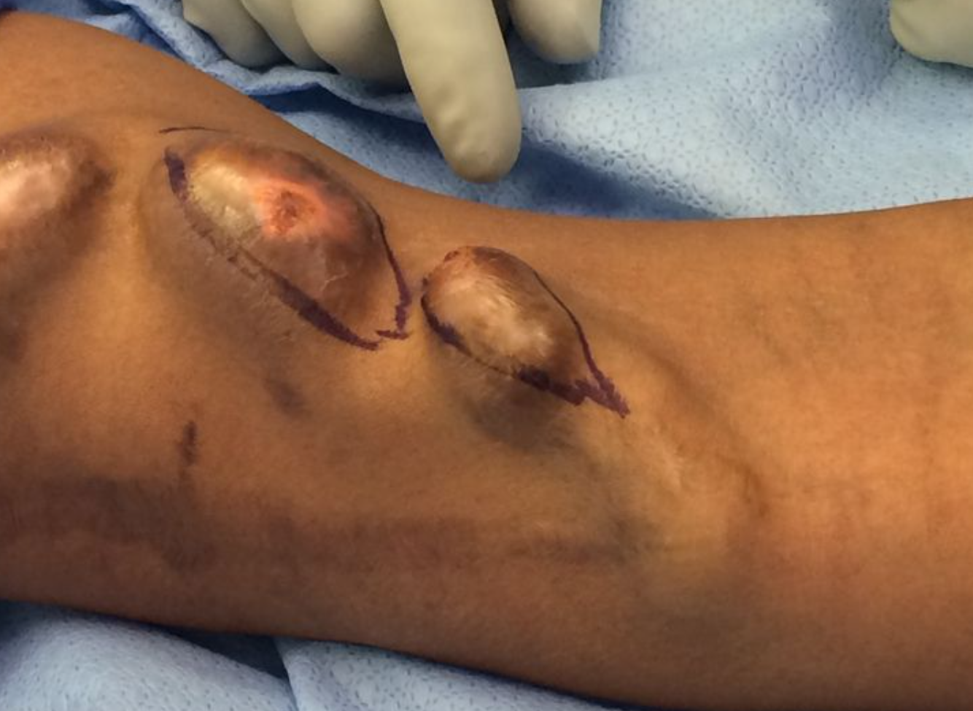
Note the scab over the puncture site and the very thin, erythematous skin.

How would you manage this patient?
- Admit the patient.
- dose of antibiotics (Ancef or Vancomycin)
- type and cross for two units of blood.
- perform a fistulogram and balloon angioplasty to alleviate the almost certain outflow stenosis.
Pitfall! If they attempt to operate on this patient without first managing the outflow:Alter the scenario such that they are then in the operating room and once they make an incision, explain that the cannulation site is now bleeding profusely with the blood hitting the ceiling. Did they place a surgical tourniquet after they prepped the arm? How will they get proximal and distal control?
- (Note:Patients with long standing, high flow arteriovenous fistulas develop outflow or central venous stenosis secondary to venous intimal hyperplasia (caused by the turbulent blood flow). Attempting surgical intervention, without first treating the outflow stenosis can lead to uncontrolled hemorrhage.)
  - place tourniquet above the area of cannulation.
  - procedure should be performed using fluoroscopy.
  - perform micropuncture cannulation of fistula.
  - exchange to 7Fr sheath over guidewire.
  - perform angiogram.
  - identify site of stenosis.

    - 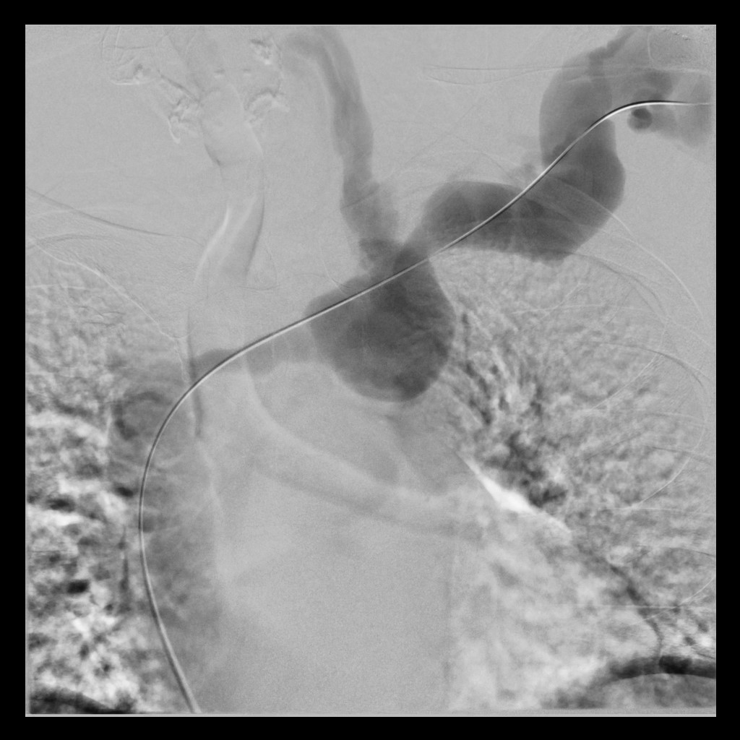
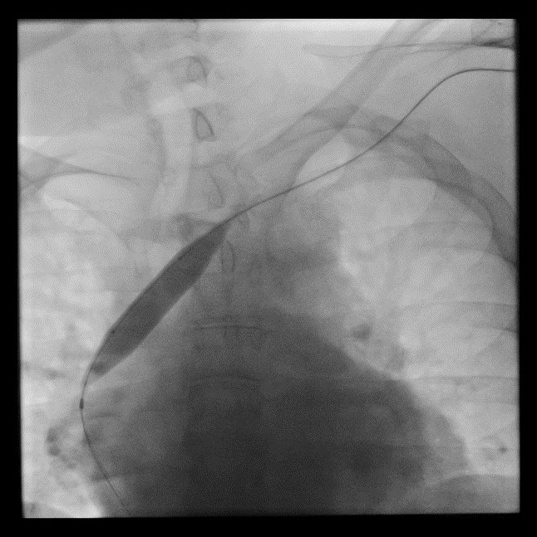
On the fistulogram, the examinee should note the contrast refluxing up the left internal jugular vein (suggesting outflow stenosis) and the narrowed innominate vein, central to the left internal jugular vein.
  - place guidewire across area of stenosis.
  - advance angioplasty balloon over guidewire.
  - perform balloon angioplasty.
  - perform completion angiogram.
  - Once the outflow stenosis has been treated, excise aneurysmal section
    - excise the anterior wall of aneurysmal sections
    - repair the fistula wall primarily (2 layers - running horizontal mattress followed by an anterior running simple layer; 3-0 or 4-0 prolene suture).
    - The subcutaneous tissue and the skin should be closed over the top.
    - Some may opt to do a bypass of this area with a PTFE or bovine graft and this is an acceptable surgical option.

Pitfalls:
- Not performing fistulogram before proceeding to OR.
- Not Using torniquet.
- Trying to put stitch in ERin the weak point of the AVF.

Reference:
- https://www.ncbi.nlm.nih.gov/pmc/articles/PMC4515897/

